

CAPSTONE PROJECT REPORT
Report 1 – Project Introduction

– Hanoi, October 2026 –
Table of Contents
I. Record of Changes 3
II. Definition and Acronyms 4
III. Project Introduction 5
1. Overview 5
1.1 Project Information 5
1.2 Project Purpose 5
1.3 Project Team 6
2. Product Background 6
2.1 Primary School Administration Context in Vietnam 6
2.2 Current School Administration Practices 7
2.3 Survey at Tân Lập A Primary School 8
2.3.1 Survey Information 8
2.3.2 Survey Questionnaire and Responses 9
2.3.3 Summary and Evidence Limitations 11
2.4 Foundations of School Administrative Workflows 12
2.5 Common Administrative Coordination Difficulties 12
2.6 Operational Documents as the Foundation for SAWP 13
2.7 Existing Working Methods and Fit Gap Analysis 15
2.8 Data Based Evidence and Analysis 15
3. Existing Solutions 18
3.1 MISA EMIS 19
3.2 vnEdu and vnEdu Connect 21
3.3 SMAS 23
3.4 eNetViet 25
3.5 Hương Việt First-level Admissions as an Upstream Boundary 26
3.6 Comparison and Conclusion 28
4. Solution and Opportunity 29
4.1 Connected Student Record and School Services 29
4.2 Supported Administrative Requests and Parent Access 29
5. Project Scope and Limitations 30
5.1 Major Features 30
5.2 Limitations and Exclusions 31
5.2.1 Limitations 31
5.2.2 Exclusions 31
6. References 32

I. Record of Changes
Date | A  M, D* | In charge | Change Description
13/09/26 | A | Project team | Created the initial draft of Report 1, including project overview and objectives.
13/09/26 | M | Project team | Refined project scope and updated the initial Product Backlog.
24/09/26 | M | Project team | Revised Section 2 to better describe the school's current administrative processes.
01/10/26 | M | Project team | Added Tân Lập A Primary School survey evidence and updated the current system analysis.

*A - Added M - Modified D - Deleted

II. Definition and Acronyms
Acronym | Definition
SAWP | School Administration and Workflow Platform; working project abbreviation.
MVP | Minimum viable product: the smallest integrated release covering the agreed core workflows.
Workflow | An ordered set of review, decision and fulfilment steps for a request.
RBAC | Role based access control: permissions assigned according to a user’s responsibilities.
SLA | Service level agreement; in this project, a configurable target processing time, not a contractual service guarantee.
Audit trail | A chronological record of who performed an action, what changed and when it occurred.
Form version | A published revision of a form whose fields and rules are preserved for submitted requests.
Guardian link | A verified association allowing a parent or guardian to act for a specific child.
Fulfilment | The work performed after approval, such as issuing a confirmation document.
UAT | User acceptance testing against agreed business scenarios.

III. Project Introduction

1. Overview

1.1 Project Information
- English name: School Administration and Workflow Platform for Primary Schools.
- Vietnamese name: Nền tảng quản lý hành chính và quy trình dành cho trường tiểu học.
- Project abbreviation: SAWP
- Group code: SEP490-G45.
- Software type: Responsive web application.

1.2 Project Purpose
SAWP is a proposed responsive web-based platform designed to support routine administrative operations within a single primary school. The system focuses on managing students who have already been officially enrolled. Authorized staff can create or import student records, manage verified guardian relationships, assign students to classes, designate homeroom teachers, and manually maintain weekly class timetables. These records support daily attendance management, leave requests, school lunch registration and cancellation, class-transfer requests, school-document requests, notifications, and operational reporting. Students are managed as school records and service beneficiaries rather than individual login users.
Parents/Guardians can access information and submit requests only for their verified linked children. Homeroom Teachers record attendance and review leave requests within their assigned responsibilities. Office Staff maintain student and class records, manage class timetables, and process assigned administrative requests. Service Staff manage available school lunch service dates, monitor meal registrations, handle authorized corrections, and review daily meal counts. The School Board reviews designated administrative requests and operational reports according to its assigned authority. System Administrators manage user accounts, permissions, system configurations, and audit records without automatically receiving authority to approve administrative requests. Approval routes, service deadlines, and escalation conditions are proposed operational assumptions that require confirmation with the participating school.
The main objectives of SAWP are to:
- Create, import, update, and maintain records of students who have already been enrolled, including duplicate-record validation, source-file references where applicable, and traceability of authorized staff actions.
- Manage verified Parent/Guardian relationships, school years, classes, student-class assignments, and homeroom teacher assignments while maintaining relevant historical records.
- Support manual creation and updating of weekly class timetables, daily attendance recording, and leave-request processing. Allow verified Parents/Guardians to register or cancel school lunch for available service dates and provide daily meal lists and registration counts.
- Process supported administrative requests, including student leave, class transfers, and school-document issuance, through role-based review and approval procedures, with request statuses, processing histories, attachments, and issued documents where applicable.
- Provide role-specific dashboards, school announcements, notifications, and operational reports covering students, classes, attendance, school lunch registration, and administrative requests, supported by role-based access control and audit logging.

1.3 Project Team
Full name | Role | Email | Mobile
Pham Ngoc Ha | Lecturer | hapn10@fe.edu.vn | 0988623000
Nguyen The Hoang Tung | Member | tungnthhe180442@fpt.edu.vn | 0965481905
Nguyen Huu An Nguyen | Member | nguyen451906@gmail.com | 0363263505
Nguyen Quang Tung | Leader | yokobang99@gmail.com | 0932278409
Dang Minh Quang | Member | phamthihongminhqt@gmail.com | 0325708358
Duong Manh Tien | Member

2. Product Background

2.1 Primary School Administration Context in Vietnam
Primary schools in Vietnam coordinate student records, class organization, attendance, school lunch services, administrative requests, and communication with families alongside teaching activities. Although these activities involve the same students, they are often managed by different staff members and follow different schedules and procedures.
Vietnam's education digital transformation policy provides a foundation for improving school administration. Decision 131/QĐ-TTg, issued on 25 January 2022, approved the national education information technology and digital transformation project for 2022–2025, with an orientation toward 2030 [18]. Guidance for the 2025–2026 school year also emphasized digital transformation, school governance, and the consistent use of education-sector data [19].
Tân Lập A Primary School was selected as the reference environment for the proposed SAWP project. According to the survey response collected by the G45 project team, the school had 845 students in 22 classes at the beginning of the 2026–2027 academic year, with approximately 720 students registered for day boarding. These figures are respondent-reported and require confirmation against official school records.
The survey also indicates that administrative information is handled through a combination of paper documents, spreadsheets, education-sector software, and communication channels such as Zalo and telephone calls. These methods support existing school operations but require coordination when information about the same student is used across attendance, school lunch services, class management, and administrative requests.
Against this background, SAWP is proposed as a responsive web-based platform for managing connected administrative activities within a single primary school. The project focuses on already-enrolled students, their verified guardians, class schedules, daily attendance, school lunch participation, selected administrative requests, notifications, and operational reporting.

2.2 Current School Administration Practices
The G45 project team collected survey information concerning administrative activities at Tân Lập A Primary School. The response describes the use of paper records, spreadsheets, education-sector software, and communication tools to support student administration and daily school operations.
Student and Class Administration
Student records and class information are maintained through existing school records and administrative software. Spreadsheets and paper documents may also be used for particular tasks. This creates a need to maintain consistent student identities, guardian contact information, and class assignments across administrative activities.
Class Timetable Management
Class timetables are prepared using spreadsheets and communicated through printed documents or class messaging groups. The Class 1A9 timetable supplied for the project identifies an effective date of 7 September 2026 [21]. This illustrates the importance of associating each timetable with a specific class and applicable period.
Attendance and Leave Management
According to the survey response, Homeroom Teachers record daily attendance and receive absence information from guardians through channels such as Zalo and telephone calls. Attendance records and leave requests are related but represent different administrative actions. The proposed system therefore maintains separate records for actual attendance and leave-request processing.
School Lunch Service Management
The survey response indicates that day-boarding participation is established at the beginning of the academic year, while the number of meals required may change from day to day. Guardians may report absences or lunch cancellations, and Homeroom Teachers help consolidate information for the staff responsible for lunch services.
The respondent reported that lunch cancellations are normally communicated before 8:00 AM and that meal information is consolidated at approximately 8:15 AM. These times are initial operational findings and require confirmation before being adopted as formal system configuration.
The school also publishes weekly lunch menus. Figure 2.2.1 presents the menu for 18–22 May 2026 [11]. The menu communicates planned meals but does not establish the number of students registered for lunch on a particular date.
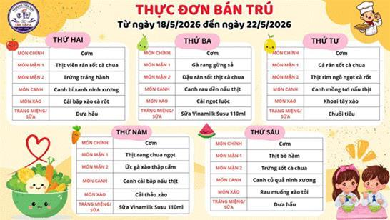
Figure 2.2.1. Tân Lập A Primary School meal menu for 18–22 May 2026. Source: school publication [11].
Administrative Requests and Communication
The survey describes administrative activities such as student leave requests, class-transfer requests, and requests for school documents. Communication among guardians, teachers, and administrative staff may involve paper forms, messaging applications, and direct contact.
These findings provide a practical basis for analyzing the proposed SAWP workflows. However, detailed approval authorities, processing deadlines, and exception-handling rules remain subject to confirmation with authorized school representatives.

2.3 Survey at Tân Lập A Primary School

2.3.1 Survey Information
The survey covers student and class information, existing administrative tools, attendance, daily lunch coordination, and document requests at Tân Lập A Primary School. The figures and procedures below reflect information recorded in the questionnaire; official operational rules remain subject to school confirmation.
Survey document: Phiếu khảo sát hiện trạng quản lý trường tiểu học – Dự án SAWP, SEP490, Nhóm G45.
School: Trường Tiểu học Tân Lập A, Cụm 5, xã Tân Lập, huyện Đan Phượng, Hà Nội
Survey date: 08/10/2026; academic year 2026–2027; reported data reference date 05/09/2026.
Respondent / role: Nguyễn Thị Đào – Phó Hiệu trưởng
Data-use consent: Có – theo nội dung câu trả lời được cung cấp.

2.3.2 Survey Questionnaire and Responses
The following questionnaire and recorded responses document current administrative practices at Tân Lập A Primary School. They cover student records, class schedules, attendance, school lunch services, administrative requests, and reporting.
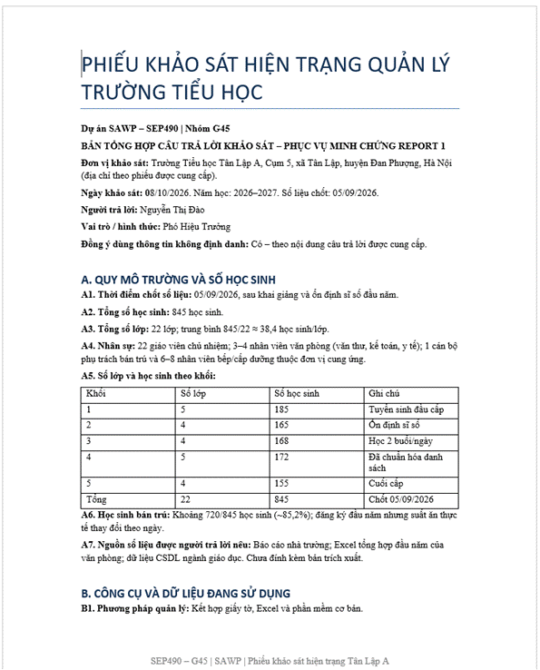
Figure 2.3.1. Survey questionnaire page 1 for Tân Lập A Primary School.
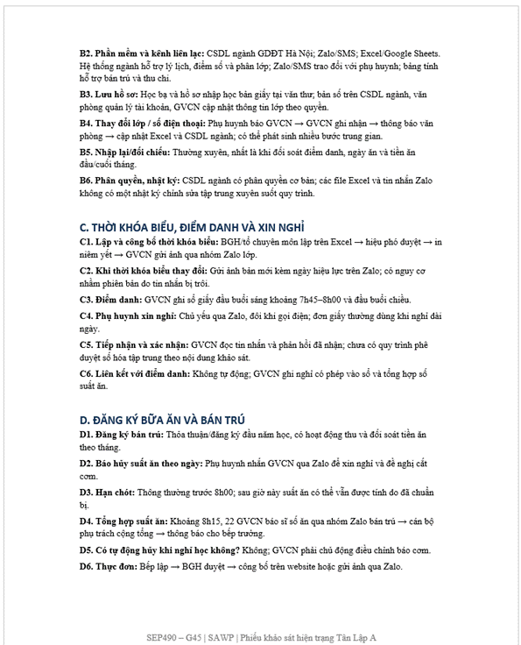
Figure 2.3.2. Survey questionnaire page 2 for Tân Lập A Primary School.
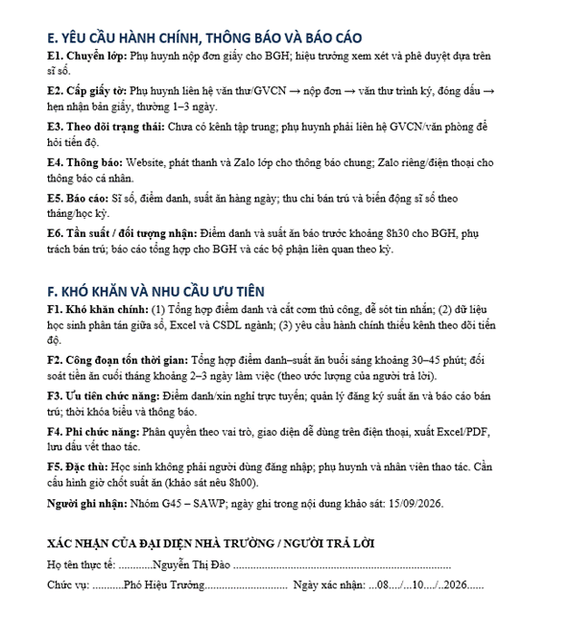
Figure 2.3.3. Survey questionnaire page 3 for Tân Lập A Primary School.

2.3.3 Summary and Evidence Limitations
The survey images in Section 2.3.2 indicate 845 students in 22 classes and approximately 720 beginning-of-year day-boarding registrations. Timetable changes, attendance messages, lunch cancellations, administrative requests, and status inquiries are coordinated through multiple channels. This supports the design rationale for connected records, date-specific lunch registrations, request tracking, notifications, and operational reports.

2.4 Foundations of School Administrative Workflows
The basis for analyzing these activities is the information carried by their documents and the actions required to complete them. Three distinctions are particularly useful: a persistent student record versus a dated activity; a submitted request versus its decision; and published information versus a record of participation.
Student and class information
A service application refers to a child and class, while the timetable organizes activities by class. These documents therefore need a reliable connection to the enrolled-student record. In SAWP, the guardian relationship and current class assignment provide that connection. Updating a contact detail or class assignment should not create a different identity for the same child.
Requests and decisions
An existing digital example is MISA’s SISAP leave-request workflow. Its published guide describes a parent submitting dates and a reason, followed by teacher confirmation or rejection; the parent can track pending and completed outcomes [22]. This demonstrates the distinction between sending information and obtaining a recorded decision. SAWP uses this distinction for its supported request types, with authority determined by the assigned responsibilities of school staff.
Schedules and dated services
The timetable describes planned class activities, whereas a daily attendance record describes actual presence. Similarly, a boarding application expresses a family’s participation request, while a daily lunch registration determines the selected service date. Keeping these concepts separate helps define precise states and avoids interpreting one record as proof of another.
These distinctions provide the domain foundation for the project. They lead to shared student information, date-specific records and explicit processing status. Detailed permissions and status transitions are defined as part of the proposed system requirements.

2.5 Common Administrative Coordination Difficulties
The survey information collected for the Tân Lập A Primary School case identifies several areas in which administrative coordination may require additional effort. The following analysis combines respondent-reported practices with the project team's interpretation of their implications for the proposed system.
Managing Information Across Multiple Tools
The survey describes the use of paper documents, spreadsheets, education-sector software, and communication applications. When different administrative activities use separate tools, staff may need to retrieve or reconcile information concerning the same student. SAWP proposes connected student and guardian records to support consistent identification across authorized workflows.
Coordinating Daily Attendance and School Lunch Information
Homeroom Teachers receive attendance and absence information and help consolidate lunch-related changes. The respondent estimated that preparing attendance and meal summaries requires approximately 30–45 minutes each morning. This estimate has not yet been verified through direct time measurement.
Tracking Administrative Requests
Leave requests, class transfers, and school-document requests may require communication among guardians, teachers, and administrative staff. SAWP proposes clear request statuses, responsible roles, and recorded processing outcomes. Exact approval responsibilities remain subject to school-level validation.
Maintaining Current Class and Schedule Information
Class assignments and timetables may change during the school year. The supplied Class 1A9 timetable demonstrates that a schedule has an effective date [21]. The proposed system associates schedules with the relevant class and applicable period.
Preparing Operational Summaries
The survey indicates that staff consolidate attendance and school lunch information from multiple classes. This supports the need for date-specific operational summaries derived from current records.
These findings support the proposed scope of SAWP, but do not prove that existing school systems are ineffective or establish a measured percentage reduction in processing time.

2.6 Operational Documents as the Foundation for SAWP
Operational documents provide concrete fields and relationships for the design. The documents below are used to understand school work and derive the relevant information needs.
A. Class timetable
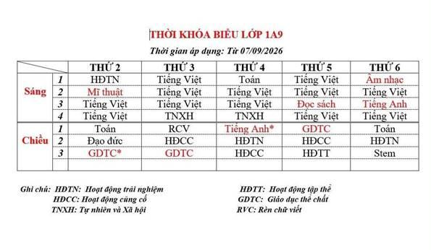
Figure 2.6.1. Class 1A9 timetable, applicable from 7 September 2026 [21].
The timetable arranges Monday to Friday against morning and afternoon sessions, with periods and subjects or activities in the corresponding cells. It identifies class 1A9 and an effective date of 7 September 2026. This supports the need to associate a schedule with a class and an effective period. For SAWP, authorized staff maintain the approved class schedule and guardians view the schedule linked to their child. Automatic timetable generation is outside the baseline scope.
B. Day boarding registration
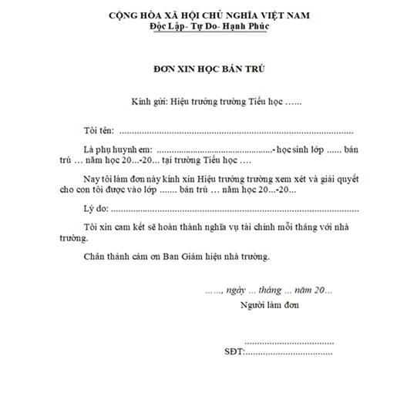
Figure 2.6.2. Sample day-boarding application used for administrative analysis [20].
The form is addressed to the primary-school principal. It asks for the parent’s name, the student’s name and class, the school year, a reason for requesting day boarding, a signature and a contact telephone number. It also includes a monthly financial commitment. The school-name field is blank in the supplied template. The form illustrates an explicit parent request associated with a particular student [20].
For the G45 design, this supports the relationship between a guardian, a student and a service request. The proposed system supports daily lunch registration, cancellation, service dates and meal counts. The annual boarding form supplies business context; it does not add annual boarding approval, supervision, billing or payment functions to SAWP. A daily lunch list must be derived from active registrations for the selected date, rather than copied directly from this annual application.
Taken together, the original class timetable, boarding application and Tân Lập A menu connect the student context to planning, participation and date-specific service information. These materials provide the operational foundation for analyzing the corresponding SAWP functions.

2.7 Existing Working Methods and Fit Gap Analysis
The survey findings and collected operational documents provide a basis for comparing existing working methods with proposed SAWP support. The analysis focuses on information and workflow coordination, not on measuring the technical performance of the school's existing software.
Existing working method | Coordination need | Proposed SAWP support
Paper student records and spreadsheets | Consistent student, guardian and class identities | Student and guardian record management
Spreadsheet timetables and printed notices | Current schedule and effective period | Manual timetable management and class schedule viewing
Attendance logs and guardian messages | Separate dated attendance and leave processing | Attendance and leave management
Day-boarding forms and daily meal summaries | Separate beginning-of-year boarding from daily meal participation | Daily lunch registration, cancellation and meal counts
Table 2.7.1. Existing working methods and proposed SAWP support, based on the Tân Lập A survey and project documents.
The comparison shows that existing methods support daily operations, while SAWP proposes to link the student record to date-specific attendance, lunch registrations, class timetables and administrative requests. Leave approval, attendance and lunch cancellation remain separate actions with distinct responsibilities.
The proposed platform is a focused, single-school administrative prototype, not a replacement for the school's official education-sector database. Its value must be assessed through functional testing and validation with authorized school representatives.

2.8 Data Based Evidence and Analysis
The survey information collected for the Tân Lập A Primary School case provides a school-specific basis for analyzing student administration, attendance, and school lunch operations. According to the survey response, the school had 845 students across 22 classes at the beginning of the 2026–2027 academic year, with approximately 720 students registered for day boarding. The reported reference date for these figures was 5 September 2026.
Measure | Value | Interpretation
Total students | 845 | Reported school enrollment at the reference date.
Total classes | 22 | Reported number of classes across Grades 1–5.
Average students per class | Approximately 38.4 | 845 ÷ 22, rounded to one decimal place.
Students registered for day boarding | Approximately 720 | Reported beginning-of-year boarding participation.
Share registered for day boarding | Approximately 85.2% | 720 ÷ 845 × 100, rounded to one decimal place.
Students not registered for day boarding | Approximately 125 | Difference between total enrollment and estimated boarding participation.
Table 2.8.1. Student and School Lunch Participation Figures Reported in the Tân Lập A Survey
The reported figures indicate that day-boarding participation represents a substantial proportion of the school's student population. However, the beginning-of-year registration total does not represent the exact number of meals required on each school day. Daily meal demand may change when guardians report absences or request lunch cancellation.
The survey response describes a daily coordination process in which Homeroom Teachers record attendance and collect absence or lunch-cancellation information from guardians, commonly through Zalo or telephone communication. Teachers then communicate meal counts to the staff responsible for school lunch operations. The reported lunch cancellation cutoff is normally before 8:00 AM, while the daily meal summary is prepared at approximately 8:15 AM.
The respondent estimated that consolidating attendance and meal information requires approximately 30–45 minutes each morning. This estimate illustrates the potential administrative workload associated with collecting information from multiple classes. It should not be interpreted as a measured processing-time baseline until verified through direct observation or operational records.
Survey Finding | Identified Administrative Need | Related SAWP Function
Student information is maintained through paper records, spreadsheets, and education-sector software. | Consistent student and guardian information across administrative activities. | Student & Guardian Record Management
Class timetables are prepared in spreadsheets and communicated through printed copies or class messaging groups. | Access to the applicable timetable and its effective date. | School Year, Class & Schedule Management
Attendance and leave information are recorded or communicated through separate channels. | Date-specific attendance records and traceable leave-request processing. | Attendance & Leave Management
Day-boarding registration is established at the beginning of the school year, while meal counts change daily. | Separation of student enrollment, boarding participation, and daily lunch registrations. | School Lunch Service Management
Class-transfer and school-document requests involve manual communication and processing. | Request submission, status tracking, review, and recorded outcomes. | Administrative Requests & School Documents
School information is communicated through the website, Zalo, telephone, and other channels. | Role-appropriate announcements and notifications. | Notifications & Announcements
Attendance and meal summaries require consolidation from multiple classes. | Date-specific operational summaries and reports. | Operational Dashboards & Reports
Table 2.8.2. Survey Findings and Implications for SAWP
The findings support the proposed SAWP scope by demonstrating relationships among student records, class schedules, attendance, leave requests, daily lunch participation, administrative requests, notifications, and reporting.
In particular, the survey highlights the importance of keeping leave approval, actual attendance, and lunch cancellation as separate records. A student's approved leave request does not automatically establish the final attendance status or cancel an existing lunch registration. These actions must follow the responsibilities and operational rules assigned to authorized users.
The proposed system therefore aims to provide connected administrative records, role-based access, date-specific information, and traceable processing outcomes. The prototype must demonstrate that these functions operate consistently across Parents/Guardians, Homeroom Teachers, Office Staff, Service Staff, the School Board, and System Administrators.
The survey questionnaire and respondent-reported results are reproduced in Section 2.3. The reported enrollment figures, operational cutoff times, and processing-time estimates should be confirmed using official school records, supporting documents, and direct observation before being treated as independently verified facts.

3. Existing Solutions
This section reviews solutions available in Vietnam with overlap in student records, attendance, timetables, parent communication, meal information or administrative processing. The admissions-only example defines an upstream activity outside SAWP. Public product materials are not hands-on tests; an undocumented capability is treated as unverified.
No. | Evaluation criterion | Question used in this review
1 | Enrolled-student record | Can staff create/import a record without duplication and retain source?
2 | Guardian and class links | Are verified relationships and effective class assignments retained?
3 | Daily attendance | Can assigned teachers record and correct attendance with audit history?
4 | Daily school lunch | Can service dates, registrations and daily meal lists be reconciled?
5 | Parent self-service | Can linked guardians view a child and submit supported requests?
6 | Roles and auditability | Are class, child and department access restrictions enforced?
7 | Administrative requests | Can leave, class transfer and document requests be reviewed and tracked?
8 | Operational reporting | Can leaders monitor class, attendance, lunch and request summaries?
9 | Fit for SAWP actors | Does the solution cover parents, teachers, staff, board and admin?
10 | Class timetable | Can staff maintain the weekly class schedule for parent viewing?

3.1 MISA EMIS
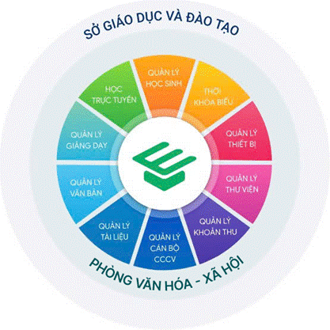
Figure 3.1.1. MISA EMIS school-management modules shown on the official product .
Description: MISA EMIS is an educational management platform developed by MISA Joint Stock Company. It supports schools in digitizing administrative and educational management activities, including student information management, staff records, and school operations. The platform provides multiple functional modules designed for educational institutions in Vietnam.
System Link: https://emis.misa.vn/emisconglap/
Core Features:
- Student, teacher, and staff information management.
- Class and educational record management.
- School administration and operational data management.
- Statistical reporting and educational management support.
- Digital storage and retrieval of school-related information.
Strengths:
- Comprehensive Educational Management: Provides multiple modules for managing student records, teachers, academic information, and school administration.
- Centralized Data Management: Supports the storage, organization, and retrieval of school-related information, reducing dependence on paper-based records.
- Reporting Capabilities: Offers statistical and reporting functions that assist administrators in monitoring educational activities.
- Alignment with Vietnamese Education Practices: Designed for educational institutions in Vietnam and their local management requirements.
- Established Market Presence: Benefits from MISA's experience in developing management software for Vietnamese organizations.
Weaknesses / Fit Gaps:
- School-Specific Administrative Workflows: MISA EMIS provides predefined educational management modules. The extent to which schools can independently configure specialized procedures, such as class-transfer requests and school-document requests, depends on the available modules and deployment configuration.
- End-to-End Request Processing: SAWP requires a consistent process for submitting, reviewing, processing, and tracking administrative requests. The availability of an equivalent workflow across all relevant MISA EMIS modules requires further verification.
- Integration of Daily Operations: SAWP focuses on connecting student records, attendance, leave requests, and daily lunch registration within a unified operational environment. The degree of integration among corresponding MISA EMIS functions may vary depending on the implemented services.
Opportunities:
- Develop a focused web platform specifically designed for routine primary school administration.
- Provide a unified interface for administrators, teachers, school staff, and parents.
- Simplify administrative request tracking and daily operational data management.
- Reduce unnecessary complexity by prioritizing functions directly related to the target school's requirements.
Threats:
- MISA's established position in the Vietnamese education software market may create strong competition.
- Schools already using MISA EMIS may prefer extending existing services rather than adopting another platform.
- Continuous development of MISA EMIS may reduce the functional differences between the two solutions.

3.2 vnEdu and vnEdu Connect
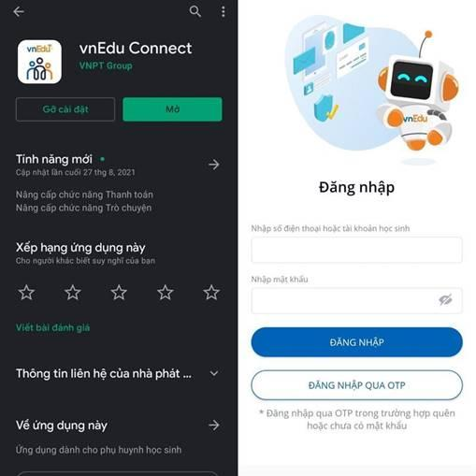
Figure 3.2.1. vnEdu Connect app listing and parent login interface. The current app description identifies attendance, timetables, communication, online services and menus .
Description: vnEdu is an educational management ecosystem developed by VNPT. It provides digital solutions for school administration, student information management, and communication between schools and families. vnEdu Connect is a parent-facing application that enables guardians to receive school notifications and access relevant student information.
System Links: https://vnedu.vn/
Parent App: https://play.google.com/store/apps/details?id=com.vnptit.vnedu.parent
Core Features:
- Student information and academic record management.
- School–parent communication and notifications.
- Attendance and academic information monitoring.
- Teacher and school administration support.
- Parent access to student-related information through mobile applications.
Strengths:
- Effective School–Parent Communication: Provides convenient channels for sharing announcements, student information, and school updates.
- Accessible Student Information: Allows parents to monitor relevant academic and attendance information through supported services.
- Integrated Educational Ecosystem: Offers a range of educational management and communication services within the VNPT ecosystem.
- Mobile Accessibility: Enables parents and teachers to access information through mobile applications.
- Established Infrastructure: Benefits from VNPT's technological infrastructure and experience in providing digital services to educational institutions.
Weaknesses / Fit Gaps:
- Administrative Request Fulfillment: Although vnEdu supports school–parent communication, the availability of complete workflows for class-transfer requests, school-document requests, and other administrative procedures depends on the implemented services.
- Attendance, Leave, and Lunch Registration Integration: SAWP requires these activities to share consistent student information and support daily operational monitoring. The extent of automatic coordination among equivalent vnEdu functions requires verification.
- School-Specific Customization: Schools may depend on the provider's available modules and configuration options when adapting workflows to their internal administrative procedures.
Opportunities:
- Build a centralized environment where parents can submit requests and monitor processing status.
- Connect leave requests, attendance records, and daily school-lunch registration through shared student data.
- Support school staff in managing daily operational tasks without relying on multiple communication channels.
- Provide a responsive web interface accessible from computers and mobile devices.
Threats:
- vnEdu benefits from VNPT's established infrastructure and educational service ecosystem.
- Existing adoption of vnEdu may reduce schools' willingness to introduce an additional platform.
- Future improvements to vnEdu's administrative and operational modules may overlap with SAWP's proposed functions.

3.3 SMAS
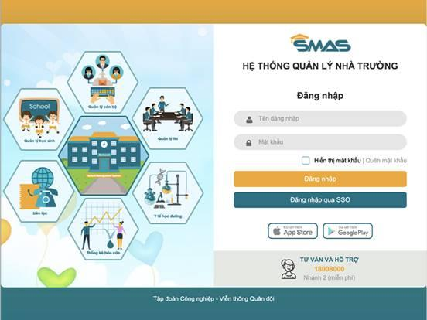
Figure 3.3.1. SMAS login interface showing school, staff, student, health, communication and reporting modules .
Description: SMAS (School Management System) is a school management platform developed by Viettel. It supports educational institutions in managing student information, teacher records, academic activities, attendance information, and educational reporting.
System Link: https://smas.edu.vn/
User Guide: https://smas.edu.vn/HDSD/PhongSo/index.html
Core Features:
- Student and teacher information management.
- Class and academic record management.
- Attendance and educational activity monitoring.
- Statistical reporting and data management.
- Support for school administration and educational management.
Strengths:
- Centralized School Management: Supports the management of student information, teachers, classes, and educational records.
- Academic and Attendance Monitoring: Provides functions for tracking student academic activities and attendance information.
- Statistical Reporting: Supports data aggregation and reporting for school administrators and educational management activities.
- Digital Record Management: Helps reduce manual paperwork by maintaining educational information electronically.
- Established Technology Provider: Benefits from Viettel's technological infrastructure and experience in delivering information technology solutions.
Weaknesses / Fit Gaps:
- Focus on Educational Data Management: SMAS provides functions for managing educational records and school information. However, the extent to which it supports complete administrative request workflows between parents and school staff requires further evaluation.
- Centralized Administrative Request Handling: SAWP aims to support leave requests, class-transfer requests, and school-document requests with clear processing statuses and role-based responsibilities. The availability of an equivalent unified workflow in SMAS has not been established.
- Daily School-Lunch Operations: SAWP requires daily lunch registration tracking and meal-count aggregation by student, class, and date. The availability and level of detail of corresponding SMAS functions need to be verified.
Opportunities:
- Develop administrative functions that complement traditional educational data management.
- Provide centralized tracking of parent-submitted requests and staff processing activities.
- Support daily lunch registration and operational reporting within the same platform.
- Improve coordination among teachers, school administrators, and authorized staff.
Threats:
- Viettel's technological infrastructure and established customer base provide significant competitive advantages.
- Schools may prefer existing management systems that are already integrated into their operations.
- Future SMAS enhancements may expand its support for school administrative services.

3.4 eNetViet
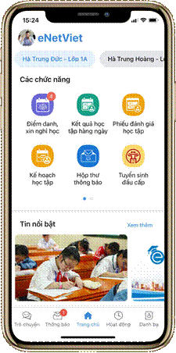
Figure 3.4.1. eNetViet parent interface on the official feature page .
Description: eNetViet is an educational communication platform designed to connect schools, teachers, and parents. It provides access to student-related information, school announcements, and communication services, supporting information exchange between educational institutions and families.
System Link: https://enetviet.com/
Parent Features: https://enetviet.com/tinh-nang-danh-cho-phu-huynh-dtnew-25000
Core Features:
- School announcements and notifications.
- Communication between teachers and parents.
- Access to student-related information.
- Support for monitoring educational activities.
- Mobile-based school–parent interaction.
Strengths:
- Convenient School–Parent Interaction: Facilitates communication and information exchange between schools, teachers, and parents.
- Timely Notifications: Supports the distribution of school announcements and student-related updates.
- Mobile-Friendly Accessibility: Provides convenient access to educational information through mobile devices.
- Improved Information Transparency: Helps parents stay informed about relevant school activities and student information.
- Communication-Oriented Design: Focuses on simplifying information exchange and strengthening connections between families and educational institutions.
Weaknesses / Fit Gaps:
- Administrative Request Processing: Communication features and leave-request submission do not necessarily provide complete workflows for reviewing, processing, recording, and returning results for different types of administrative requests.
- Back-Office Operations: SAWP requires authorized school staff to receive, review, and process student-related requests through dedicated management functions. The extent of equivalent administrative support in eNetViet requires further verification.
- Operational Data Integration: SAWP aims to maintain consistent student and class information across attendance, leave requests, lunch registration, and notifications. The level of integration among corresponding eNetViet functions depends on the connected systems and deployed services.
Opportunities:
- Extend beyond school–parent communication by supporting internal administrative processing.
- Provide role-based interfaces for teachers, school staff, administrators, and parents.
- Connect request processing with student records and daily school operations.
- Improve transparency by allowing authorized users to monitor request status and processing results.
Threats:
- eNetViet's existing mobile application and communication services may be familiar to parents and teachers.
- Schools may prefer retaining their established communication platforms.
- Additional administrative features introduced in future versions could reduce SAWP's differentiation.

3.5 Hương Việt First-level Admissions as an Upstream Boundary

Figure 3.5.1. Hương Việt Group illustration for its online first-level admissions solution [7].
Description: The Huong Viet First-Grade Admission System is considered an upstream educational administration solution that supports the admission process for students entering primary school. Its primary purpose is to facilitate admission registration, application processing, and admission-result management.
Unlike routine school administration platforms, admission systems mainly operate before students officially begin their studies. SAWP does not replace the admission process. Its operational scope begins after students have been admitted to the school.
System Link: https://huongvietgroup.com/linh-vuc-hoat-dong/phan-mem-quan-ly-tuyen-sinh-dau-cap-truc-tuyen.html
Core Features:
- First-grade admission registration and application submission.
- Applicant information collection and management.
- Admission application processing.
- Admission result management and announcement.
- Generation and export of admission-related student lists, depending on system capabilities.
Strengths:
- Digital Admission Registration: Supports electronic collection and management of first-grade admission applications.
- Centralized Applicant Information: Helps organize applicant records and admission-related data during the enrollment process.
- Admission Process Support: Facilitates application processing and admission-result management.
- Reduced Manual Data Entry: Can reduce reliance on paper-based admission procedures and manual record organization.
- Initial Student Data Availability: Provides admission-related information that may serve as a starting point for student record creation after enrollment.
Weaknesses / Fit Gaps:
- Limited Operational Lifecycle Coverage: The admission system primarily focuses on the enrollment stage. SAWP addresses subsequent school operations, including class assignment, attendance, leave requests, lunch registration, and administrative services.
- Additional Operational Data Requirements: Admission information may not contain all the details required for daily school management, such as homeroom teacher assignments, guardian relationships, class schedules, and lunch registration records.
- Student Data Transition: Schools need a method to transfer or enter admitted student information into their operational management system. The availability of automated integration depends on the admission system's supported interfaces and deployment conditions.
- Different Functional Scope: Admission registration, admission evaluation, and admission-result publication are outside SAWP's scope. SAWP focuses on managing students after admission.
Opportunities:
- Support authorized staff in creating or importing student records after the admission process.
- Establish consistent student, guardian, class, and homeroom teacher information for daily administration.
- Provide continuity in student information management throughout primary school operations.
- Avoid duplicating admission-related functionality by focusing on post-admission administration.
Threats:
- Differences in admission data formats may require additional data preparation before import.
- Changes in external admission systems may affect future data exchange requirements.
- Schools using comprehensive educational management solutions may prefer to continue managing student records within their existing systems.

3.6 Comparison and Conclusion

Criteria | MISA EMIS | vnEdu | SMAS | eNetViet | Hương Việt
Main Purpose | Manages school activities and student information. | Manages school data and connects schools with parents. | Manages student records and school reports. | Connects teachers, schools, and parents. | Manages first-grade admissions.
Student Management | Manages student profiles and records. | Manages student and academic information. | Stores student records and school data. | Shows student information to parents. | Manages admission applications.
Class Management | Manages classes and teachers. | Manages classes and student lists. | Manages classes and teacher assignments. | Shows class and teacher information. | Focuses on admission records.
Timetable | Supports timetable creation and management. | Shows class timetables. | Timetable features need verification. | Allows parents to view timetables. | Not part of its main purpose.
Attendance | Records student attendance. | Tracks student attendance. | Manages attendance records. | Shows attendance information. | Not supported within its admission scope.
Leave Requests | Parents can submit leave requests through SISAP. | Leave request features need verification. | Parent leave request features need verification. | Parents can send leave requests. | Not part of its main purpose.
Daily Lunch Registration | Daily registration needs verification. | Provides meal information; daily registration needs verification. | Daily registration needs verification. | Shows menus; daily registration needs verification. | Not part of its main purpose.
Class Transfer Requests | Request workflow needs verification. | Request workflow needs verification. | Request workflow needs verification. | Request workflow needs verification. | Not part of its main purpose.
School Document Requests | Request processing needs verification. | Request processing needs verification. | Request processing needs verification. | Request processing needs verification. | Focuses on admission documents.
Notifications | Sends school notifications through SISAP. | Sends notifications through vnEdu Connect. | Provides school communication services. | Supports messages and school notifications. | Sends admission updates.
Reports | Provides school management reports. | Provides student and school reports. | Provides school reports and statistics. | Reporting depends on connected services. | Provides admission reports.
Major Limitations | Integration of daily tasks and administrative requests needs verification. | Integration of daily school activities needs verification. | Parent request and daily lunch features need verification. | Mainly focuses on communication; administrative workflows need verification. | Only focuses on admissions, not daily school management.

4. Solution and Opportunity
SAWP is a proposed single-school prototype. Tân Lập A's public Grade 1 plan and weekly boarding menu establish dated administrative outputs [9], [11], but do not reveal its internal attendance and meal-registration processes. The proposed functions remain subject to validation with authorized school staff.

4.1 Connected Student Record and School Services
Authorized staff create or import records for already enrolled students, link verified guardians, maintain school years and classes, assign homeroom teachers and students, and manage the weekly class subject timetable. A student can then be referenced by daily attendance, leave, lunch-service dates, requests, notifications and reports. Effective dates and relevant changes should remain traceable.
The platform connects administrative record management with daily school operations. Office Staff maintain student and guardian information, class assignments, and weekly class timetables. Homeroom Teachers use their assigned class records to manage attendance and review relevant leave requests. Parents/Guardians can view information and submit permitted requests for their verified linked children. Service Staff configure available lunch-service dates, monitor registrations, perform authorized corrections, and review daily meal lists and counts. Relevant changes are recorded to maintain accountability and traceability.
The initial release serves one school. Teachers record and correct attendance within assigned classes; guardians see linked children's records and may register or cancel school lunch for configured dates; Lunch Service Staff review daily lists and counts. The cutoff, exception and absence-reconciliation rules are explicit prototype assumptions. The system does not decide admission or automatically generate academic timetables.

4.2 Supported Administrative Requests and Parent Access
Parents submit supported leave, class-transfer and school-document requests for verified linked children and track their statuses. Assigned teachers, Office Staff and the School Board review or decide according to the request type; an authorized staff member applies an approved class transfer or issues a requested document. In-system notifications and audit logs record relevant changes. The specific routes and authorities are proposed until confirmed at Tân Lập A.
The request path separates submission, review, decision and fulfilment. A linked guardian submits a leave, class-transfer or supported school-document request; the responsible teacher or Office Staff reviews it, and the School Board decides only cases assigned to its authority. An approved transfer updates class history, while an approved document request ends with a recorded issued document. Notifications convey changes in status but do not themselves constitute approval. These workflows remain subject to confirmation of the school's actual responsibilities.

Workflow | Proposed route to validate with the school | Completion evidence
Student record | School-provided enrolled-student data → Office Staff create/import → guardian/class links | One student record, source and assignment
Attendance and leave | Teacher marks daily attendance; linked guardian submits leave; assigned role reviews | Dated record and status history
Daily school lunch | Configure available date → guardian register/cancel → staff reconcile meal list | Daily registration and meal count
Class transfer / document | Guardian request → assigned review → decision/fulfilment | Updated class history or issued document
Class timetable | Authorized staff enter/update weekly schedule → make available to class | Current class schedule visible to linked guardians

5. Project Scope and Limitations

5.1 Major Features
The following feature tree presents the major functional areas of SAWP, covering student and guardian records, class and timetable management, attendance and leave, school lunch services, administrative requests, notifications, operational reporting, and system administration. The proposed functions are designed for a single primary school and are subject to validation of school-specific operational rules.
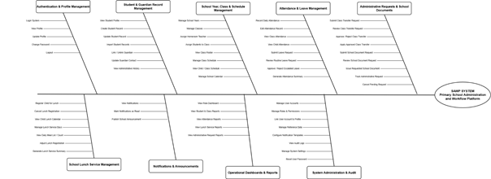
Figure 5.1. Partial feature tree for SAWP.

5.2 Limitations and Exclusions

5.2.1 Limitations
● LI01: The system is designed to support the management activities of a primary school; therefore, its functions and workflows are based on the school's organizational structure, regulations, and actual operating procedures.
● LI02: The accuracy and completeness of student, guardian, class, timetable, attendance, and boarding information depend on the data provided and updated by authorized school staff.
● LI03: The system supports the management and monitoring of school activities but does not replace the responsibility of teachers and school administrators in verifying information and making official decisions.
● LI04: The system supports three types of administrative requests: student leave requests, class-transfer requests, and school-document requests. Their review, approval, and processing procedures follow the responsibilities and operational rules established by the school. Additional request types are outside the baseline scope.
● LI05: Class Timetable Management: SAWP supports manual creation, updating, and publication of weekly class timetables by authorized Office Staff. Automatic timetable generation, scheduling optimization, and teacher workload optimization are outside the baseline scope.
● LI06: School Lunch Service: SAWP supports date-specific meal registration, cancellation, authorized corrections, and daily meal counting. Monthly planning may be supported through the selection of multiple service dates. The system does not manage full boarding supervision, nutrition planning, food procurement, or meal payments.

5.2.2 Exclusions
● EX01: The system does not cover student admission campaigns, applicant evaluation, admission ranking, waiting lists, admission decisions, or other admission-selection processes.
● EX02: Students are not provided with individual system accounts. The system does not provide online learning, examinations, grading, academic performance evaluation, or conduct assessment.
● EX03: Examination schedules, examination rooms, examination shifts, and other examination-management activities are not included in the system.
● EX04: The system does not provide automatic timetable generation, teacher/room optimization, or automatic class scheduling.
● EX05: Financial functions such as tuition fee management, payroll, accounting, invoicing, and online payment processing are outside the scope of the system.
● EX06: Comprehensive Boarding and Meal Operations: Full boarding supervision, student rest monitoring, nutrition management, food procurement, meal preparation, and school lunch fee collection are excluded from the baseline scope.
● EX07: The system is intended for the management of a single primary school and does not include multi-school or school-chain management.

6. References
[1] MISA EMIS. “Nền tảng quản lý giáo dục – MISA EMIS Công lập.” Accessed 16 September 2026. https://emis.misa.vn/emisconglap/
[2] MISA EMIS. “Tính năng – Phần mềm quản lý trường học.” Accessed 16 September 2026. https://emis.misa.vn/emisconglap/tinh-nang/
[3] vnEdu. “Hướng dẫn sử dụng vnEdu.” Accessed 16 September 2026. https://doc.vnedu.vn/
[4] VNPT IT. “vnEdu Connect” on Google Play. Accessed 16 September 2026. https://play.google.com/store/apps/details?id=com.vnptit.vnedu.parent
[5] Viettel. “SMAS – Hệ thống quản lý nhà trường” and SMAS user guide. Accessed 16 September 2026. https://smas.edu.vn/HDSD/PhongSo/index.html
[6] eNetViet. “Tính năng dành cho Phụ huynh” and “Tính năng dành cho Giáo viên.” Accessed 16 September 2026. https://enetviet.com/tinh-nang-danh-cho-phu-huynh-dtnew-25000
[7] Hương Việt Group. “Phần mềm quản lý tuyển sinh đầu cấp trực tuyến.” Accessed 16 September 2026. https://huongvietgroup.com/linh-vuc-hoat-dong/phan-mem-quan-ly-tuyen-sinh-dau-cap-truc-tuyen.html
[8] Hương Việt Group. “Tuyển Sinh Đầu Cấp” on Google Play. Accessed 16 September 2026. https://play.google.com/store/apps/details?id=com.huongvietgroup.tuyensinh
[9] Trường Tiểu học Tân Lập A. “Kế hoạch tuyển sinh vào lớp 1 năm học 2026–2027.” Accessed 16 September 2026. https://thtanlapa.danphuong.edu.vn/tin-tuc-su-kien/ke-hoach-tuyen-sinh-vao-lop-1-truong-tieu-hoc-tan-lap-a-nam-hoc-2026-2027.html
[10] Trường Tiểu học Tân Lập B. “Kế hoạch 82/KH-THTLB tuyển sinh lớp 1 năm học 2026–2027.” Published 1 April 2026. Accessed 16 September 2026. https://thtanlapb.danphuong.edu.vn/tin-tuc-su-kien/cong-khai/ke-hoach-tuyen-sinh-vao-lop-1-truong-tieu-hoc-tan-lap-b-nam-hoc-2026-2027.html
[11] Trường Tiểu học Tân Lập A. “Thực đơn bán trú từ ngày 18/05/2026 đến ngày 22/05/2026.” Accessed 16 September 2026. https://thtanlapa.danphuong.edu.vn/tin-tuc-su-kien/thuc-don-ban-tru-tu-ngay-18-05-2026-den-ngay-22-05-2026.html
[12] Trường Tiểu học Tân Lập B. “Thông báo về việc ăn bán trú tại trường năm học 2025–2026.” Published 12 July 2025. Accessed 16 September 2026. https://thtanlapb.danphuong.edu.vn/tin-tuc-su-kien/cong-khai/thong-bao-ve-viec-an-ban-tru-tai-truong-nam-hoc-2025-2026.html
[13] Government of Vietnam. “Circular 15/2026/TT-BGDĐT issuing the Charter for primary, lower-secondary, upper-secondary and multi-level schools.” Issued 24 March 2026; effective 10 May 2026. Accessed 24 September 2026. https://chinhphu.vn/?classid=1&docid=217678&pageid=27160&typegroupid=6
[14] Government of Vietnam. “Decree 13/2023/NĐ-CP on personal data protection.” Issued 17 April 2023; effective 1 July 2023. Accessed 16 September 2026. https://vanban.chinhphu.vn/?docid=207759&pageid=27160
[15] MISA EMIS. “EMIS Thời khóa biểu.” Product brochure. Accessed 24 September 2026. https://emis.misa.vn/emisconglap/qlth/documents/Thoi_khoa_bieu.pdf
[16] eNetViet. “Tính năng dành cho Phụ huynh.” Accessed 24 September 2026. https://enetviet.com/tinh-nang-danh-cho-phu-huynh-dtnew-25000
[17] MISA EMIS. “MISA EMIS - Nền tảng giáo dục đáp ứng đầy đủ nghiệp vụ quản lý học sinh tại trường Tiểu học.” Product brochure. Accessed 24 September 2026. https://emis.misa.vn/emisconglap/qlth/documents/QuanLy_HocSinh.pdf
[18] Prime Minister of Vietnam. Decision 131/QĐ-TTg, 25 January 2022. Education IT and digital transformation project 2022–2025, orientation to 2030. https://chinhphu.vn/?classid=2&docid=205236&pageid=27160 Accessed 29 September 2026.
[19] Government Policy Portal. Guidance 4555/BGDĐT-GDPT for general education in 2025–2026. 4 September 2025. https://xaydungchinhsach.chinhphu.vn/cong-van-4555-bgddt-gdpt-huong-dan-thuc-hien-nhiem-vu-giao-duc-pho-thong-nam-hoc-2025-2026-119250805205608703.htm Accessed 29 September 2026.
[20] Sample “Đơn xin học bán trú” administrative form. Blank template reproduced for business-process analysis; school-name field is blank.
[21] Class 1A9 timetable, applicable from 7 September 2026. Document provided for analysis of school scheduling practices.
[22] MISA. SISAP Phụ huynh: Phụ huynh quản lý nề nếp học tập và nộp đơn xin nghỉ cho con. Updated 29 April 2026. https://emishelp.misa.vn/kb/672/ Accessed 29 September 2026.
[23] Hanoi Fatherland Front. Chủ tịch Ủy ban MTTQ Việt Nam thành phố Hà Nội dự lễ khai giảng tại Trường Tiểu học Vương Thừa Vũ. 7 September 2026. https://mttqhanoi.org.vn/chu-tich-uy-ban-mttq-viet-nam-thanh-pho-ha-noi-du-le-khai-giang-tai-truong-tieu-hoc-vuong-thua-vu.htm Accessed 29 September 2026.

